ECE 313 Lecture Notes
Lecture 5 on Sampling & Aliasing Part 2 Version 2.0
Thursday, September 17, 2026
By TA Alice Liu
…
Demonstration of aliasing with video of helicopter take-off
- Video: camera shutter speed and frame rate match helicopter`s rotor
- Depending on size of helicopter blades, rotations are anywhere from 225 – 500 revolutions/min, or equivalently from 3.75 – 8.33 revolutions/s
…
Brief Q&A on Midterm #1 Exam
- Previous midterm #1 exams and their solutions available on the midterm #1 page
- Question: Will we be required to write MATLAB code on exams?
  - Answer: No, not required. But students can choose to.
- Upcoming midterm on Thursday, October 1, 11:00am-12:15pm (lecture time)
- Question: Is exam open note?
  - Answer: Yes, open book, notes, laptop.
  - NO Internet or other communication networks (NO online MATLAB, only local MATLAB installed on your laptop)
  - NO AI tools
- Question: How should we prepare?
  - Answer: Each student is different and studies differently. There are various resources available to students (lecture slides, lecture notes, handouts, textbook, practice problems, past homeworks/exams, etc…)
…
Moving on to Lecture 5 on Sampling & Aliasing
Sampling
- Continuous to Discrete time signal
  - Capturing continuous time signal at uniformly spaced time intervals to get Sampled Discrete time signal
- Reconstruction
  - Discrete to Continuous time signal
    - Reconstruction of discrete time signal to continuous time signal
    - Interpolation between samples
      - Linear interpolation (“connect the dots” where the dots are the samples)
    - For sampling rate high enough, we see less artifacts in the plot representation of Discrete time signals
- Plotting in Continuous… plot(…)
- Plotting in Discrete… stem(…)
- Sampling Theorem
  - A continuous time signal with frequency components no greater than f_{max} can be reconstructed exactly from its samples if sampled at rate f_{s} > 2 f_{max}
  - Tradeoff?
    - Higher sampling rate better signal reconstruction
      - Eventually we have diminishing returns (example: no visible/audible difference for signal reconstructed at 100 kHz versus 44.1 kHz)
    - Higher sampling rate more data per second (higher storage, processing and compute requirements)
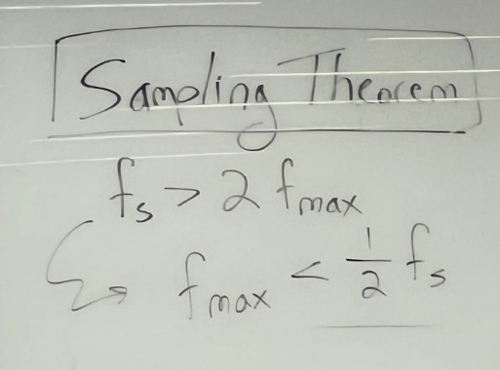
  - The reverse is true: given sampling rate f_{s}, you can sample signals and capture frequencies up to ½ f_{s}

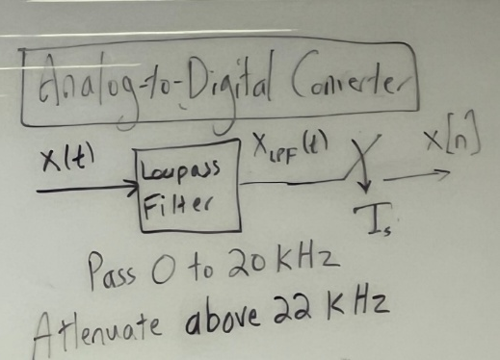
  - Example:
    - A Lowpass Filter to pass up to 20 kHz and attenuate frequencies 20-22 kHz
    - Meaning, f_{max} = 22 kHz
    - Thus, we must sample at
f_{s} > 2 f_{max} where
2 f_{max} = 2*22 kHz = 44 kHz
    - Meaning, we sample the signal’s amplitude in continuous time every T_{s} = 1 / f_{s} seconds
    - In practice, the analog lowpass filter response will have a band of frequencies (20-22 kHz) that transition from passing frequencies 0-20 kHz to attenuating frequencies above 22 kHz. Frequencies above 22 kHz will be attenuated (reduced) but not completely eliminated.
  - Question: What if we sample first and then filter?
    - Answer: If we sample first, then any frequencies higher than ½ f_{s} will alias to frequencies between -½ f_{s} and ½ f_{s}
  - Question: What do you mean by aliasing?
    - Answer: We’ve not yet defined it (to come), but an example is the helicopter aliasing demo at the start of lecture. The helicopter blades were rotating but due to sampling rate (frame rate) of the video camera on the shore, the blade appear to be still (0 Hz).
  - What has an Analog-to-Digital Converter?
    - Sensors, microphones, cellular device receivers… etc
    - An A/D Converter converts an analog continuous-time signal into a digital discrete-time signal
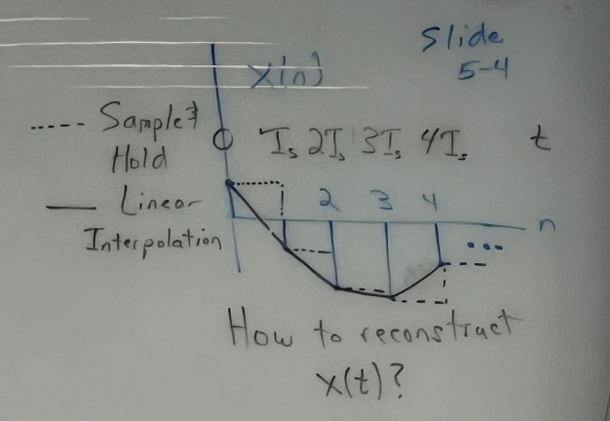
- Reconstruction – Interpolation types
  - Linear interpolation – draw straight lines to connect adjacent samples
  - Zero-order Hold, also known as Sample & Hold (benefit = simplicity)
  - Curve-fitting

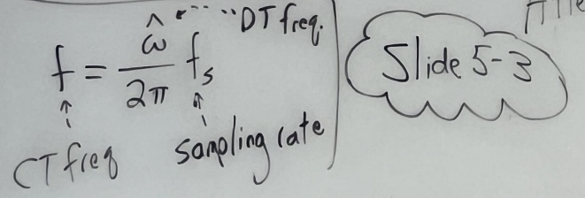
- Sampling
  - Converts a continuous-time (CT) signal to a discrete-time (DT) signal
  - Can derive the relationship between CT and DT frequencies by sampling sinusoidal signal
    - New normalized sampling frequency: “discrete-time frequency”
    - Omega-hat = w^ = w*T_s = 2*pi*f/f_s
    - Normalized means w^ is restricted to a range of 2*pi
  - Discrete-time frequency directly affects the signal sampling & reconstruction

- How should one sample?
  - Ensure f_s > 2*f_max
  - Oversampling: f_s >> 2*f_max
  - Undersampling (aliasing): f_s < 2*f_max
  - Question: Why do we oversample, if we just need 2*f_max?
    - Sampling Theorem is just to capture the frequency content
    - In practice, oversampling allows us to better track the time-domain amplitudes and have a higher quality reconstruction of the signal
Aliasing
- Aliasing occurs when we don’t satisfy Sampling Theorem, when f_s <= 2*f_max
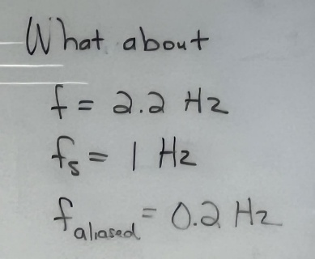
- Aka: We can no longer exactly determine the original frequency components
  - Do frequency components come from original signal?
  - Do frequency components come from aliased signal?
- Infinite number of frequencies that will alias to the same low frequency…
  - As a result of the sampling
  - Slide 5-9: Example using f_{s} = 1 Hz. When the continuous-time sinusoid has a frequency of 1.2 Hz, the aliased frequency will be 0.2 Hz. For a continuous-time sinusoidal frequency of 2.2 Hz, the aliased frequency will be 0.2 Hz.

